Oracle Installation

1. Install JDK in your system. If it already installed, skip this step.
2. Install Oracle 11g Express Edition. Use default settings. It will ask password. Please note it down your given password carefully!
3. After rebooting your system, click on “Get started with Oracle 11g...” application

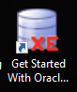

1. Click on ‘Application Express’ tab.

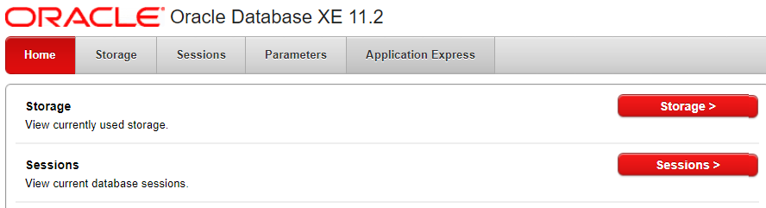

1. It will ask Username/password. Use SYSTEM as user and give the password which you had given at the time of installation.

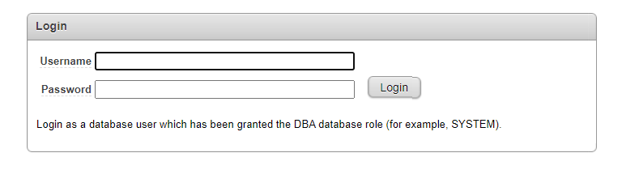

1. Create a new user giving your name and your password. Use same password everywhere. Click on Create Workspace.

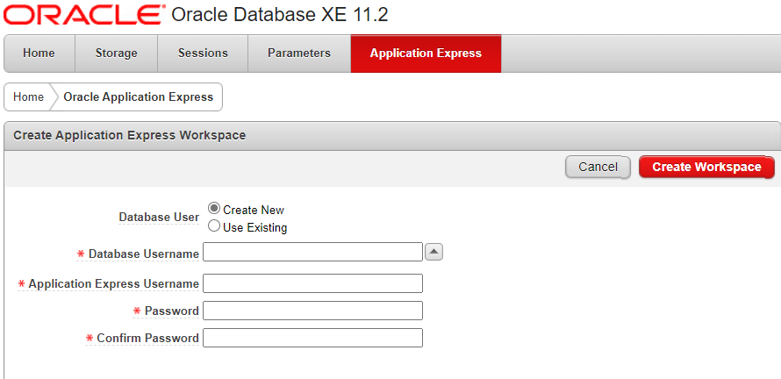

1. Now Install SQL Developer. It will ask the path of JDK. After rebooting click on SQL Developer. 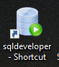
2. Create a connection by clicking + sign in the top left corner and give details in the following window. Click on Test. If connection successfully established, it will not show any error message.

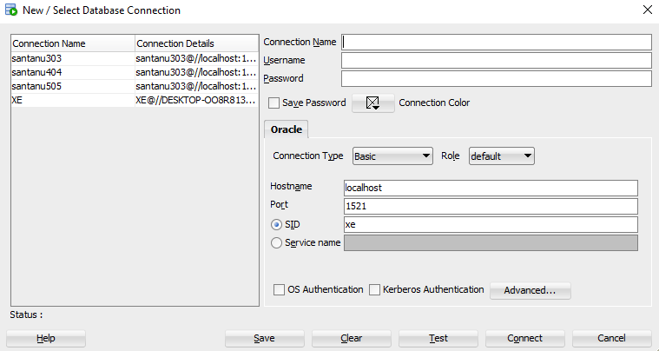

1. Now you can start browsing your DB objects in the schema browser.

